Código Conexao.php:

<?php

class Conexao{

    public static function pegarConexao()

    {

        $host = "localhost";

        $dbname = "bdtime";

        $usuario = "root";

        $senha = "";

        global $conexao;

        try {

            //Conexão local com bdempregaki

            $conexao = new PDO(

                "mysql:host=$host;

                dbname=$dbname",

                "$usuario",

                "$senha"

            );

            $conexao->setAttribute(PDO::ATTR_ERRMODE, PDO::ERRMODE_EXCEPTION);

            $conexao->exec("SET CHARACTER SET utf8");

        } catch (PDOException $e) {

            echo "Connection failed: " . $e->getMessage();

            exit();

        }

        return $conexao;

    }

}

?>

Código graficos.php:

<!DOCTYPE html>

<html>

<head>

    <script type="text/javascript" src="https://www.gstatic.com/charts/loader.js"></script>

</head>

<body>

    <?php include('Conexao.php');?>

    <section style="width:81%;margin: 0 auto; display:table;">

        <div>

            <h1 style="text-align:center;font-size:2.5em; margin-top:30px;"> Exemplo com Gráfico </h1>

        </div>

        <a href="pdf.php">

            <button style="float: right;">

                Gerar PDF

            </button>

        </a>

        <div style="float:left;">

            <div id="chart_div"></div>

        </div>

        <div style="float:left;">

            <div id="chart_div2"></div>

        </div>

    </section>

</body>

</html>

<script type="text/javascript">

    google.charts.load('current', {

        'packages': ['corechart']

    });

    google.charts.setOnLoadCallback(drawChart);

    function drawChart() {

        var data = new google.visualization.DataTable();

        data.addColumn('string', 'Topping');

        data.addColumn('number', 'Slices');

        data.addRows([

            <?php

            $i = 0;

            $conexao = Conexao::pegarConexao();

            $stmt = $conexao->prepare("SELECT idTime,nomeTime FROM tbtime

                                    ORDER BY idTime");

            $stmt->execute();

            while ($row = $stmt->fetch(PDO::FETCH_BOTH)) {

                echo ("['" . $row['nomeTime'] . "'," . $row['idTime'] . "],\n");

                $i++;

            }

            ?>

        ]);

        var options = {

            'title': 'Taxa de Popularidade (2021)',

            'width': 500,

            'height': 300,

            slices: {

                0: {

                    color: 'orange'

                },

                1: {

                    color: 'red'

                },

                2: {

                    color: 'green'

                },

                3: {

                    color: '#00f'

                }

            }

        };

        var chart = new google.visualization.PieChart(document.getElementById('chart_div'));

        chart.draw(data, options);

    }

    google.charts.load('current', {

        packages: ['corechart', 'bar']

    });

    google.charts.setOnLoadCallback(drawAnnotations);

    function drawAnnotations() {

        var data = google.visualization.arrayToDataTable([

            ['Element', 'Times daoras', {

                role: 'style'

            }],

            <?php

            $i = 0;

            $color = array(

                0 => 'orange',

                1 => 'red',

                2 => 'green',

                3 => 'blue',

                4 => 'purple'

            );

            $conexao = Conexao::pegarConexao();

            $stmt = $conexao->prepare("SELECT idTime,nomeTime FROM tbtime

                                        ORDER BY idTime");

            $stmt->execute();

            while ($row = $stmt->fetch(PDO::FETCH_BOTH)) {

                $nomeTime[$i] = $row['nomeTime'];

                $idTime[$i] = $row['idTime'];

                $i++;

            }

            for ($i = 0; $i < count($nomeTime); $i++) {

                echo "['$nomeTime[$i]',$idTime[$i],'$color[$i]'],\n";

            }

            ?>

        ]);

        var options = {

            title: 'Maiores Times do Mundo na Atualidade',

            'width': 585,

            'height': 300,

            annotations: {

                alwaysOutside: true,

                textStyle: {

                    fontSize: 14,

                    color: '#000',

                    auraColor: 'none'

                }

            },

            hAxis: {

                title: '<--Ruim :Times: Bom-->',

                format: 'h:mm a',

                viewWindow: {

                    min: [7, 30, 0],

                    max: [17, 30, 0]

                }

            },

            vAxis: {

                title: 'Escala (Do Pior Até o Melhor)'

            }

        };

        var chart = new google.visualization.ColumnChart(document.getElementById('chart_div2'));

        chart.draw(data, options);

    }

</script>

Print graficos.php:

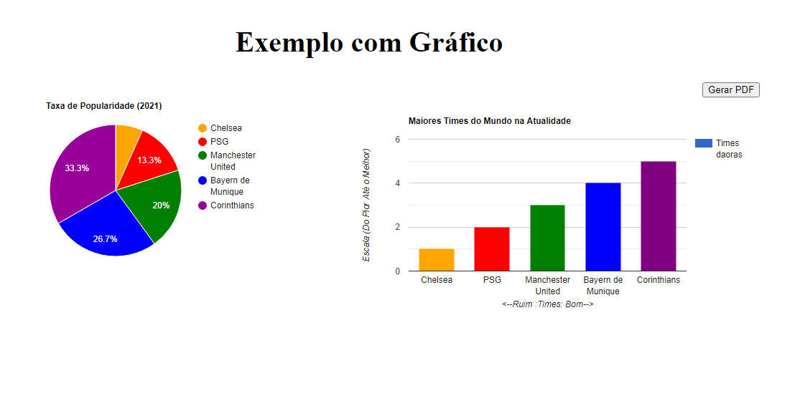

Código pdf.php:

<?php

    use Dompdf\Dompdf;

    require_once("dompdf/autoload.inc.php");

    include ('Conexao.php');

    $dompdf = new DOMPDF();

    $conexao = Conexao::pegarConexao();

    $stmt = $conexao->prepare("SELECT idTime,nomeTime FROM tbtime

                            ORDER BY idTime");

    $stmt->execute();

    $table = "<table border='1'>";

    $table .= "<tr>";

    $table .= "<th>ID</th>";

    $table .= "<th>Nome</th>";

    $table .= "</tr>";

    while ($row = $stmt->fetch(PDO::FETCH_BOTH)) {

        $table .= "<tr> <td>".$row['idTime']."</td>" ;

        $table .= "<td>".$row['nomeTime']."</td> </tr>" ;

    }

    $table .= "</table>";

    $dompdf->load_html("

    <!DOCTYPE html>

    <html>

        <head>

            <meta charset='utf-8'>

            <title>PDF - Gráfico</title>

        </head>

        <body>

            <h1 align='center'>

                Título do relatório

            </h1>

            <h4>

                Tabela: tbtime

            </h4>

            $table

        </body>

    </html>

    ");

    $dompdf->setPaper('A4', 'portrait'); //landscape = Modo paisagem, portrait = Modo retrato

    $dompdf->render();

    $dompdf->stream(

        "certificado.pdf",

        array(

            "Attachment" => false //Para realizar o download do pdf,basta alterar para true

        )

    );

?>

Print pdf.php:

